DAA LAB

1)

2)

3)

4)

5)

6)

7)

8)

9)

10)

11)

12)

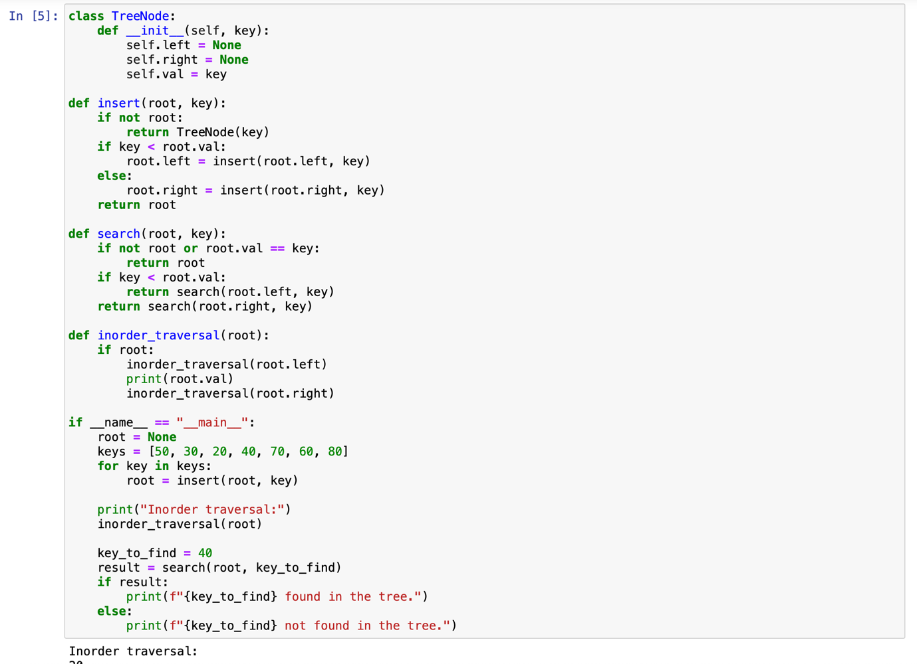

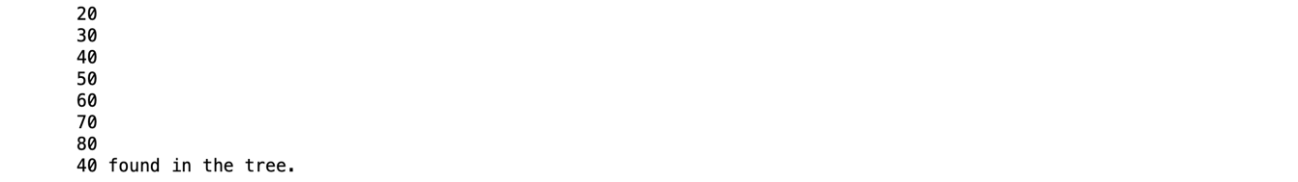

Q.13)

14)

15)

16)

17)

18)

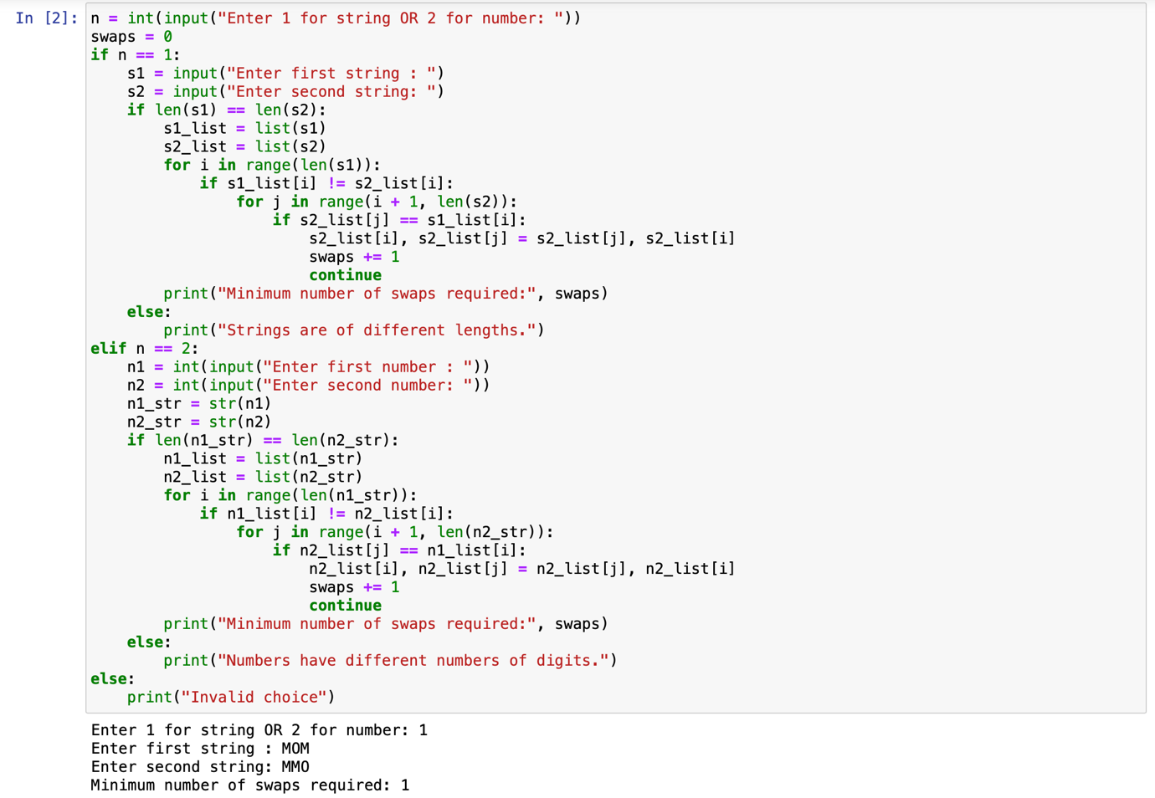

19)

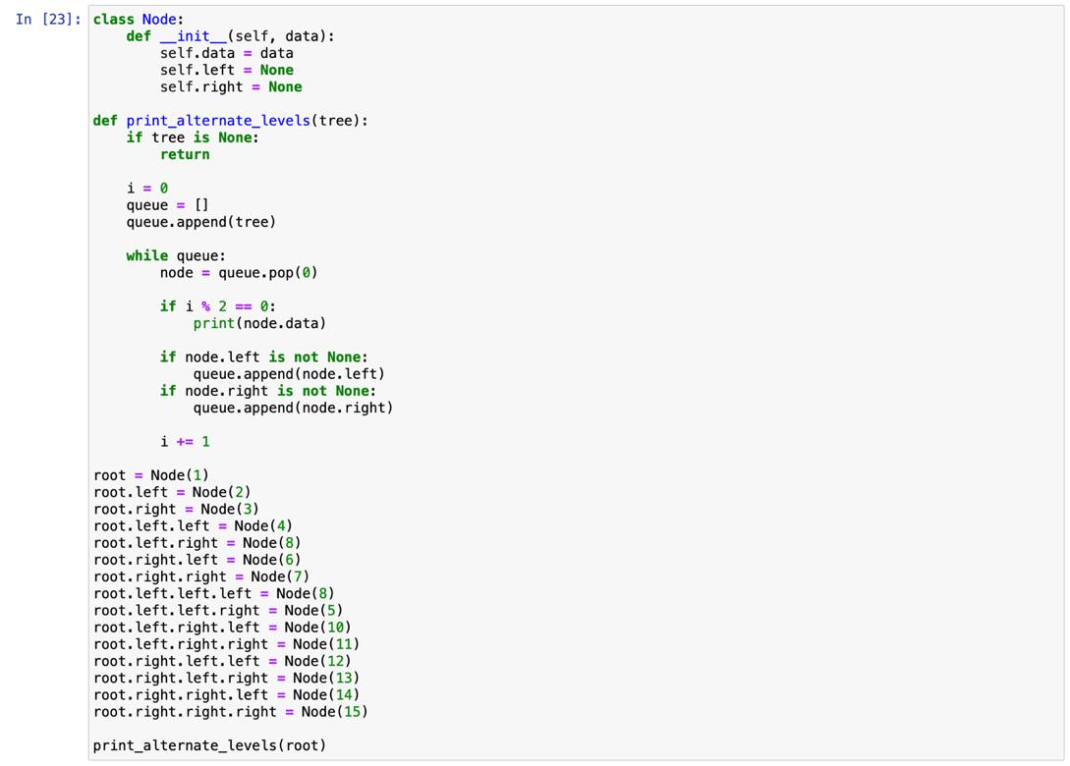

20)

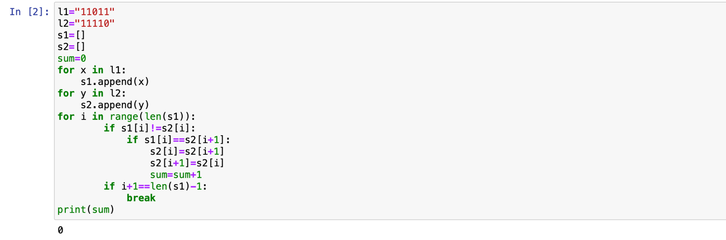

21)



